**Structure and Functions assignments**

Mandatory

1. Refer the code in “student.c”. Implement the following requirements.

a. Change the name member to char * datatype

b. Add 2 functions below to read and store name and percentage scores from user in student record.

//pass name address as parameter and read and update name field Return updated name

char *read_update_name(char *name);

//pass address of percentage as parameter, read and update percentage field of student record. Also return updated percentage

int read_update_percentage(int *percent);

c. Check for memory leaks

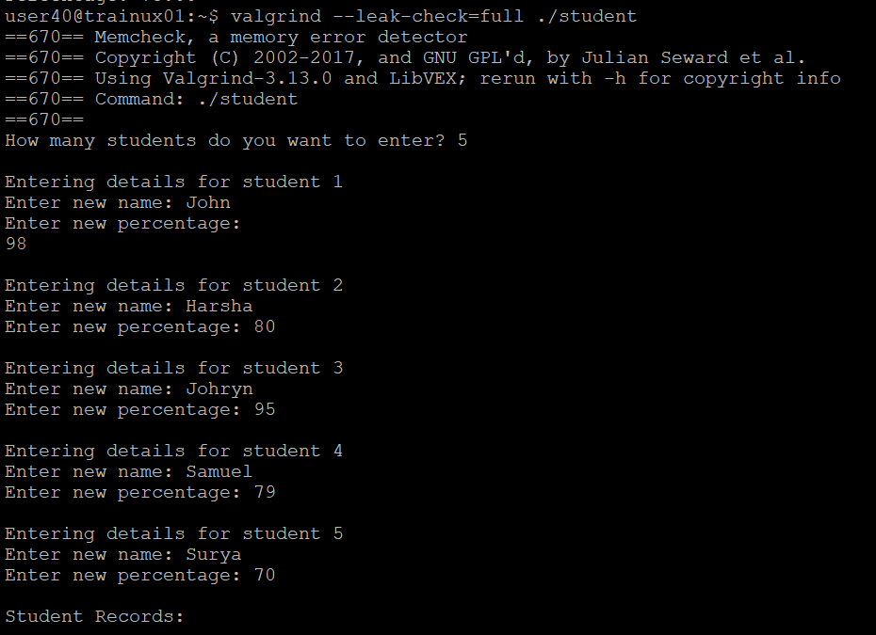

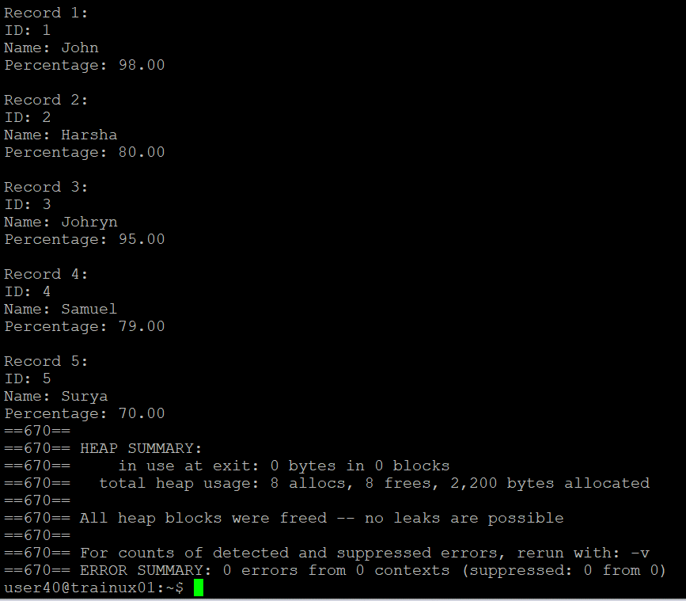

d. Specify atleast 5 dataset used for testing

Check for memory leak

